**EXPERIMENT-4**

**Title:** Use of Inbuilt functions and relational algebra operation.

**Objective:** To understand the use of inbuilt function and relational algebra with sql query.

**1. Create the following two tables**

**Table name:** EMP

**Code:**

use lab_work;

CREATE TABLE EMP (

EMPNO int,

ENAME varchar(30),

JOB varchar(30),

MGR varchar(30) ,

HIREDATE date ,

SAL int,

COMM varchar(30),

DEPTNO int REFERENCES DEPT ( DEPTNO)

);

**Table name:** DEPT

**Code:**

use lab_work;

CREATE TABLE DEPT (

DEPTNO int primary key,

DNAME varchar(30),

LOC varchar(30)

);

**2. Reinsert the data in these tables.**

**Table name:** EMP

**Code:**

use lab_work;

INSERT INTO EMP

VALUES ('7369', 'SMITH' ,'CLERK', '7902', '1980-12-17','500', '800','20'),

('7499' ,'ALLEN' ,'SALESMAN' ,'7698' ,'1981-02-20' ,'1600' ,'300','30'),

('7521', 'WARD', 'SALESMAN', '7698', '1981-02-22', '1250', '500', '30'),

('7566' ,'JONES' ,'MANAGER' ,'7839' ,'1981-04-02' ,'2975' ,'','20'),

('7654', 'MARTIN', 'SALESMAN', '7698', '1981-09-28', '1250', '1400', '30'),

('7698' ,'BLAKE' ,'MANAGER' ,'7839' ,'1981-05-01' ,'2850' ,'','30'),

('7782', 'CLARK', 'MANAGER' ,'7839', '1981-06-09', '2450','' ,'10'),

('7788', 'SCOTT', 'ANALYST', '7566', '1982-12-09', '3000', '','20'),

( '7839', 'KING', 'PRESIDENT', '','1981-11-17', '5000','','10'),

('7844' ,'TURNER' ,'SALESMAN' ,'7698' ,'1981-09-08' ,'1500' ,'0','30'),

('7876', 'ADAMS', 'CLERK' ,'7788', '1981-01-12', '1100','', '20'),

('7900' ,'JAMES' ,'CLERK' ,'7698' ,'1981-12-03' ,'950' ,'','30'),

('7902', 'FORD', 'ANALYST', '7566', '1981-12-03', '3000','', '20'),

('7934' ,'MILLER' ,'CLERK' ,'7782' ,'1982-01-23' ,'1300','' ,'10');

**Table name:** DEPT

**Code:**

use lab_work;

INSERT INTO DEPT

VALUES ( '10', 'ACCOUNTING', 'NEW YORK'),

('20' ,'RESEARCH' ,'DALLAS'),

('30', 'SALES', 'CHICAGO'),

('40' ,'OPERATIONS' ,'BOSTON');

**3. Display the contents of each table**

**Code:**

use lab_work;

select * from EMP ;

select * from DEPT ;

**Output:**

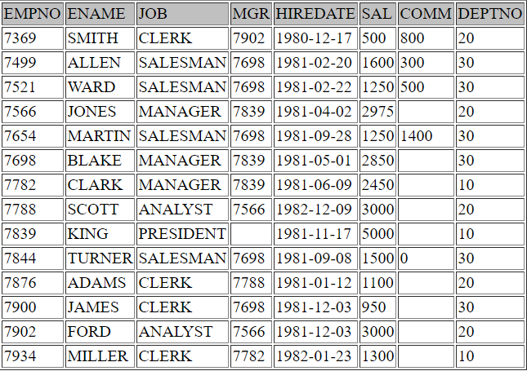

**EMP**

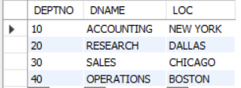

**DEPT**

**4.Write the Nested Queries for the following queries.**

1. List the details of the emps whose Salaries more than the employee BLAKE.

**Code:**

use lab_work;

select * from EMP where SAL>( select SAL from EMP where ENAME='BLAKE');

**Output:**

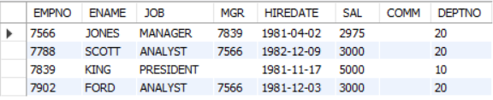

2. List the emps whose Jobs are same as ALLEN.

**Code:**

use lab_work;

select * from EMP where JOB = (select JOB from EMP where ENAME ='ALLEN');

**Output:**

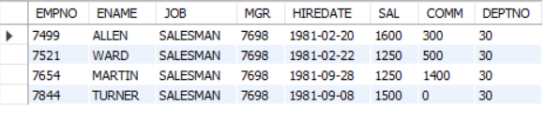

3. List the Emps whose Sal is same as FORD or SMITH in desc order of Names.

**Code:**

use lab_work;

Select * from EMP where SAL in (select SAL from EMP where ( ENAME = 'SMITH' or ENAME = 'FORD' )) order by SAL desc;

**Output:**

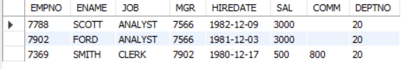

4. List the emps Whose Jobs are same as MILLER or Sal is more than ALLEN.

**Code:**

use lab_work;

select * from EMP where JOB = (select JOB from EMP where ENAME ='MILLER' ) or

SAL>(select SAL from EMP where ENAME = 'ALLEN');

**Output:**

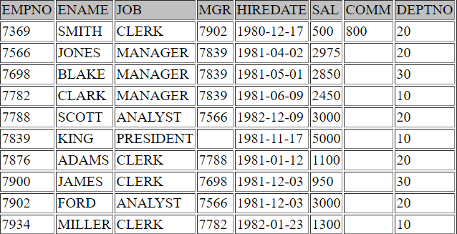

5. Find the highest paid employee of sales department.

**Code:**

use lab_work;

select * from EMP where sal in (select max(SAL) from EMP where DEPTNO=(select DEPTNO from DEPT where DNAME= 'SALES'));

**Output:**



6. List the employees who are senior to most recently hired employee working under king.

**Code:**

use lab_work;

select * from EMP where HIREDATE < (select max(HIREDATE) from EMP where MGR

in (select EMPNO from EMP where ENAME= 'KING')) ;

**Output:**

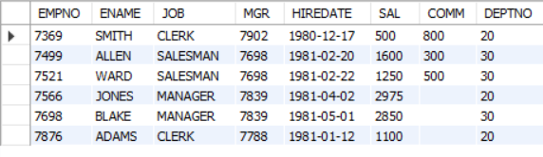

7. List the names of the emps who are getting the highest sal dept wise.

**Code:**

use lab_work;

select ENAME, DEPTNO from EMP where SAL in

(select max(SAL) from EMP group by DEPTNO) ;

**Output:**

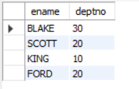

8. List the emps whose sal is equal to the average of max and minimum .

**Code:**

use lab_work;

select * from EMP where SAL =(select (max(SAL)+min(SAL))/2 from EMP);

**Output:**



**No Data Found**

9. List the emps who joined in the company on the same date.

**Code:**

use lab_work;

select * from EMP E where HIREDATE in

(select HIREDATE from EMP where E.EMPNO <> EMPNO);

**Output:**

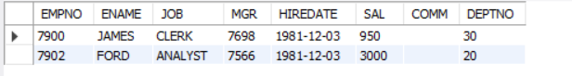

10. Find out the emps who joined in the company before their Managers.

**Code:**

use lab_work;

select * FROM EMP E WHERE HIREDATE < (select HIREDATE FROM EMP WHERE EMPNO = E.MGR);

**Output:**

